**Brian Leahy ASSIGNMENT 5 17372896**

Q1.

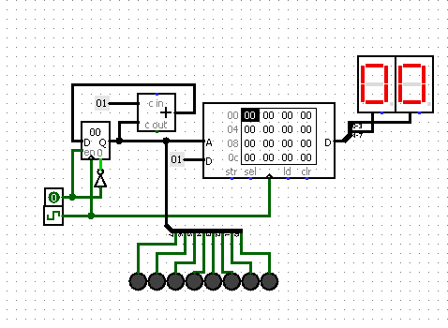

Q2.

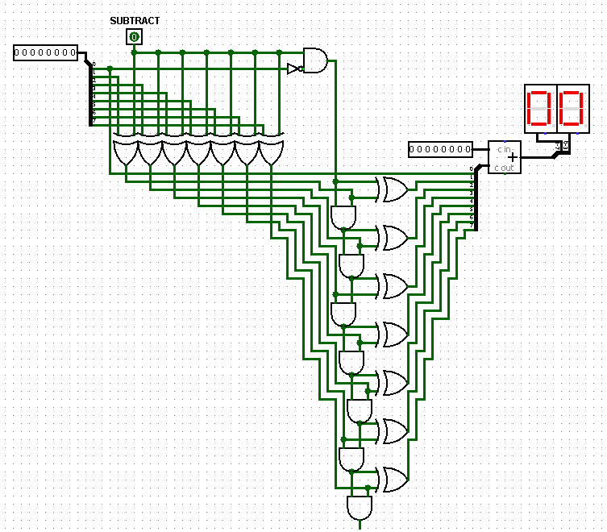

Q3.

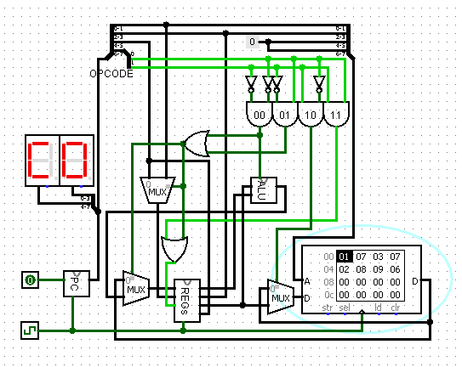

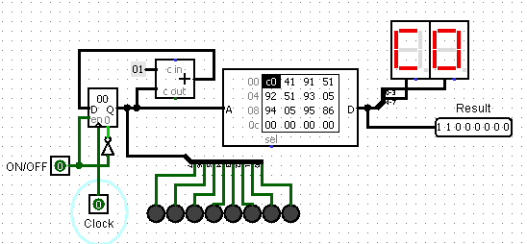

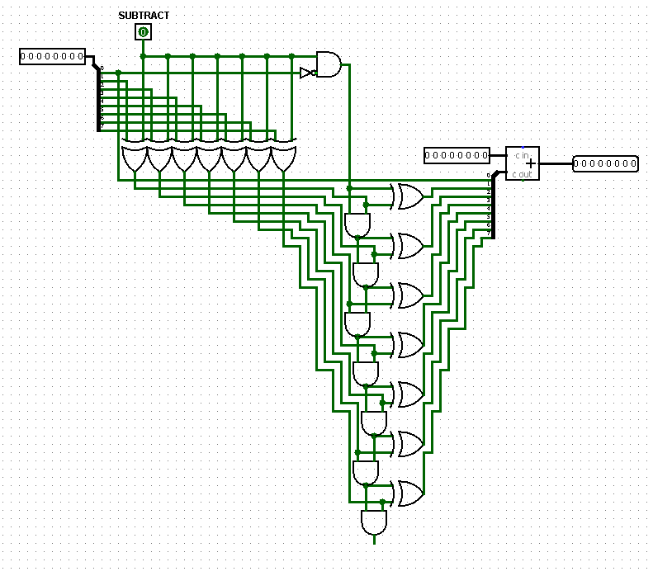

Q4. A) Code takes value stored in 00 in memory as x.

Machine Code: 11000000 01000001 10010001 01010001 10010010 01010001

10010011 00000101 10010100 00000101 10010101 10000110

Hex Code: c041 9151 9251 9305 9405 9586

Assembly Code: lb $zero, 0x0000

add $t0, $zero, $zero

sb $t0, 0x0001

add $t0, $zero, $t0

sb $t0, 0x0010

add $t0, $zero, $t0

sb $t0, 0x0011

sub $t0, $t0, $zero

sb $t0, 0x0100

sub $t0, $t0, $zero

sb $t0, 0x0101

sb $zero, 0x0110

Final Result with my student number stored in data ram: 1,2,3,4,3,2,1,6

(My student number is 17372896)

